
Save the Date:
Pinckney’s Arise United Methodist Church is happy to host this years
Vacation Bible School “B.O.O.T Camp”
July 11-14th 6:00pm - 8:30 pm Dinner, skits, music, storytelling, crafts, and games!
And it’s all FREE! Come join us for lots of fun! Our own Sgt. Robert, who is a veteran of the United States Army will be our “Drill Sergeant”!
Visit www.arisechurch.org for more details.

Just for Fun!
Q: How can you tell elephants love to travel?

A: They are always packing their trunk!

Q: What did baby corn say to mama corn?
A: Where's popcorn?”

Q: Why do golfers take an extra pair of socks?
A: In case they get a hole in one!

Q: How do I avoid infection from biting insects?
A: Easy - don't bite them.

Q: Why did the baby strawberry cry?
A: Because his dad was in a jam!

Q: What is the most tired part of your car?
A: The exhaust pipe.

Q: What did daddy spider say to baby spider?
A: You spend too much time on the web.

Q: What do you call your dad when he falls through the ice?
A: a POPsicle!

A: What kind of car does a bull have?
Q: A bulldozer.

Q: How did the soldier fit his tank in his house?
A: It was a fish tank!

Parenting/Marriage Support Group:
Please consider attending a small group of Arise parents and couples to discuss the natural occurrences in raising a family in the Christian faith. We meet monthly, for a potluck meal, at alternating homes, the kids play, and the parents discuss whatever is on their hearts. We need new people; all are welcome!
Contact Carrie Germain at carrie@germain.us for the next meeting, location, and further details if you’re interested.

End of the School Year Prayer
Christ, Teacher and Lord,
Bless all in this school
As we seek to end our year
With the grace you so generously provide.
We give thanks for the students
And the faculty, the administrators,
And all who have contributed
To this year of nurturing and growth.
We affirm all the positive moments,
Of insight, of the excitement of learning,
Of accomplishment, of creativity,
Of laughter, of a sense of community.
We recognize the times of struggle,
Of difficult work, of misunderstanding,
Even of failure--we give these
To you for transformation,
So they can become seeds
That will find fertile soil.
As we leave for the summer,
May we take with us
The knowledge that
You will keep us all
In your embrace so
We may rest and be restored
And so we can continue in
The ongoing discovery
of your Love.
Amen.

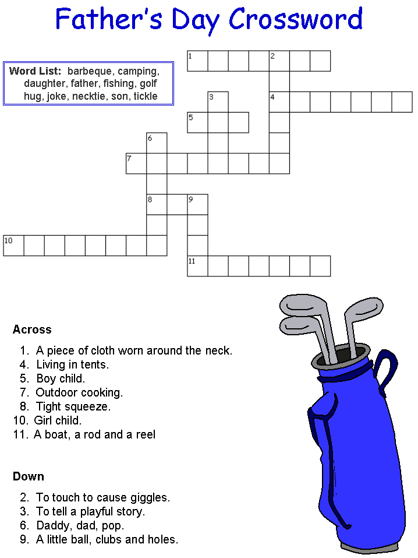x.]

